Name: Nadeem Ahmed Khan

STUDENT MANAGEMENT SYSTEM

Using (python and MySql)

**Description:**

This system is created to collect data of students and to enter marks and student details. It has a option for clerk to register and then login to enter data and marks of student in the table and then that can be removed,updated or exported to excel file for further analyzing and storing.

**Working:**

* The first page is login page, correct username and password is required. Wrong information will lead to try again.
* After login, various fields are to be filled in order to make an entry. The fields are first name, last name, email id, contact number and marks detail.
* On click of insert data will be entered into the database.
* On click of refresh data can be fetched from database to the program and displayed.
* On click of remove entrys can be removed.
* On click of export to excel data can be exported to excel file.
* On click of marks another form will be opened for marks entry

**Modules:**

* **Python :** a programming language with many features
* An object-oriented interface
* Support for prepared statements
* Support for multiple statements
* Support for transactions
* Enhanced debugging support
* Embedded server support
* More powerful Functionality
* **Mysql:**The database is used to store the details of the sudent and the marks.
* Microsoft excel: it is used to store the data from the database to excel file.

ScreenShot:

Login page:

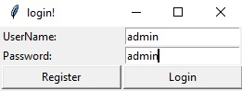

Mai n page:

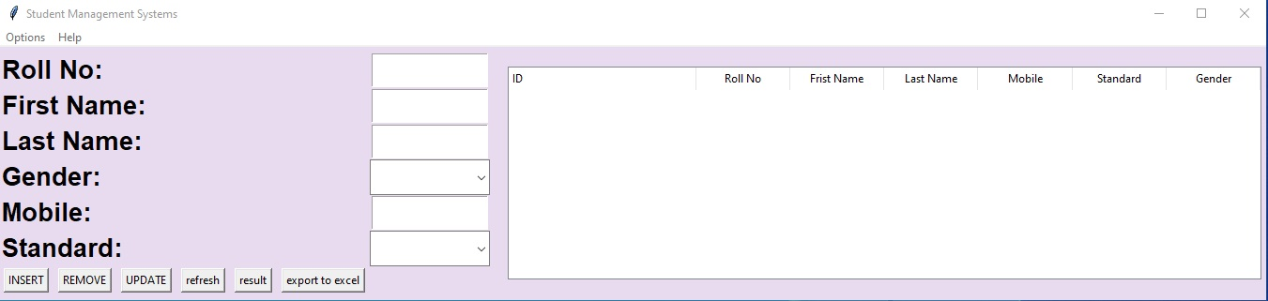

Refreshed details:

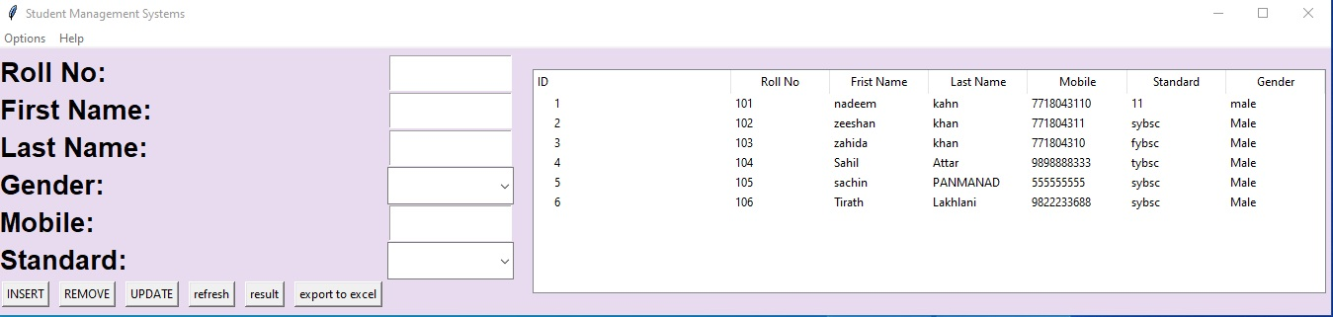

Mark details:

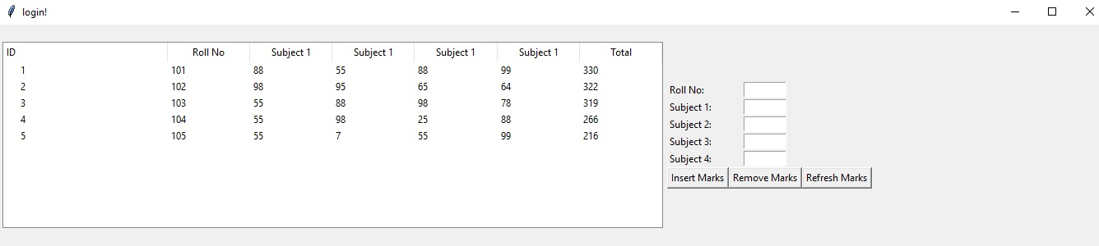

Export to Excel:

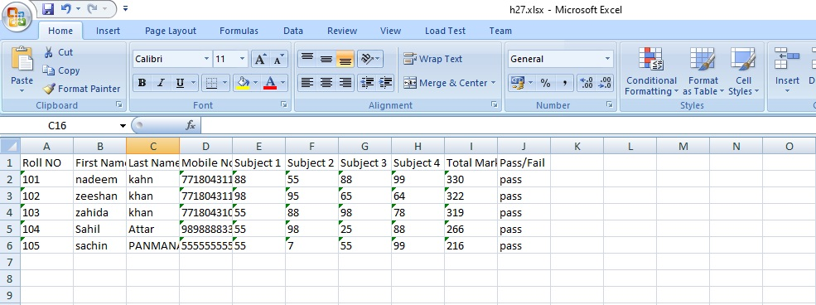

Password file:

